Use case diagram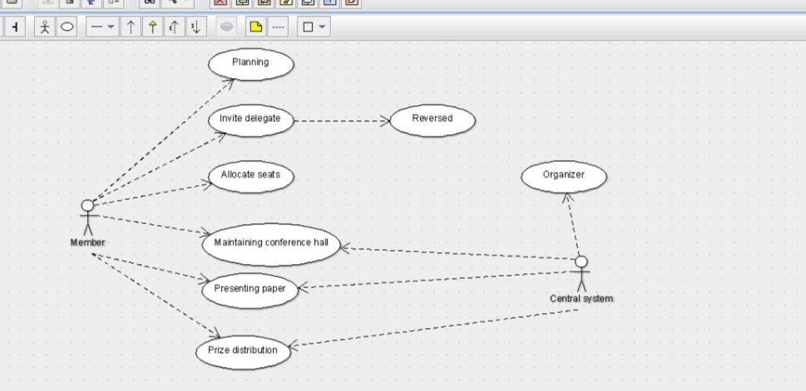

CLASS DAIGRAM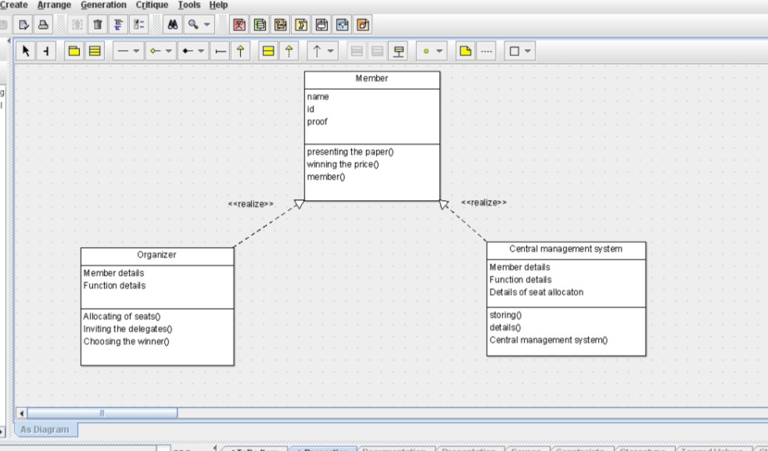

public class Central management system {

public Member details;

public Function details;

public Details of seat allocaton;

public void storing() {

}

private void details() {

}

public void Central management system() {

}

}

public class Member {

public name;

public id;

public proof;

public void presenting the paper() {

}

public void winning the price() {

}

public void member() {

}

}public class Organizer {

public Member details;

public Function details;

public void Allocating of seats() {

}

public void Inviting the delegates() {

}

public void Choosing the winner() {

}

}

SEQUENCE DIAGRAM

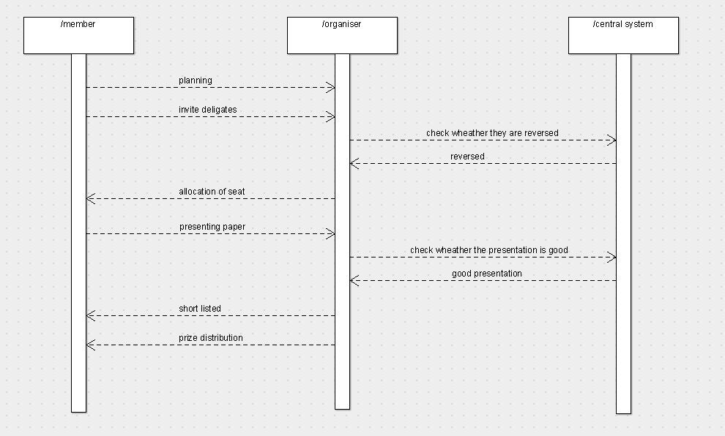

COLLABORATION DIAGRAM

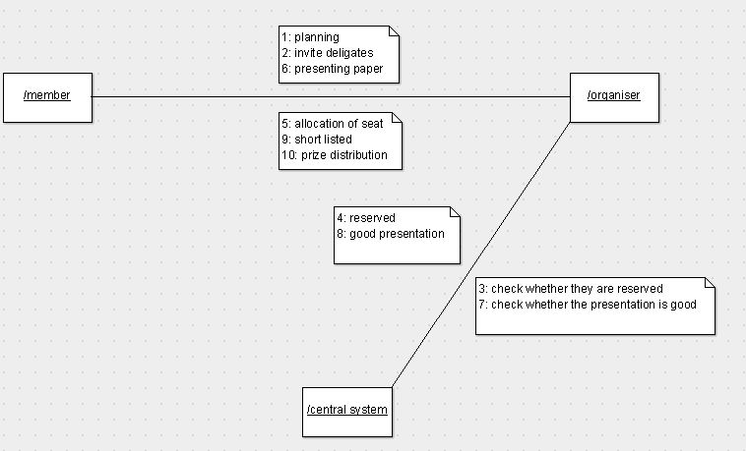

ACTIVITY DIAGRAM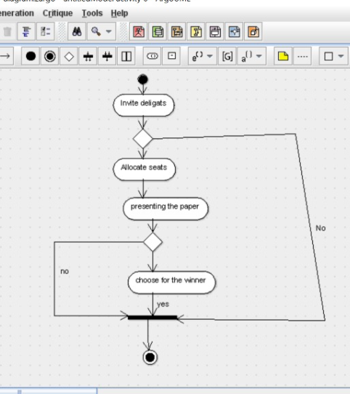

COMPONENT DIAGRAM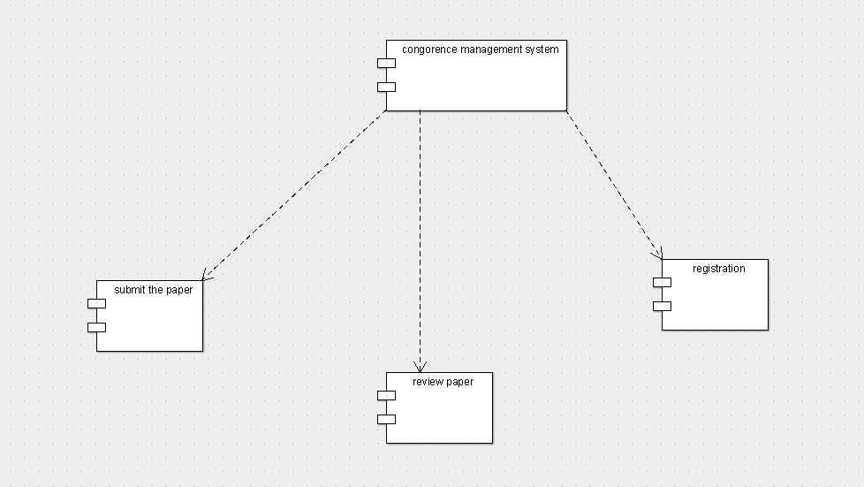

DEPLOYMENT DIAGRAM